

**Topic: Search Tips**

Searching for a document in **theSource** is an easy and important tool to help you perform your daily activities.

**theSource** provides you with several options to help you accomplish an effective Search:

1. **Search bar**

* Enter the document information and click the magnifying glass:

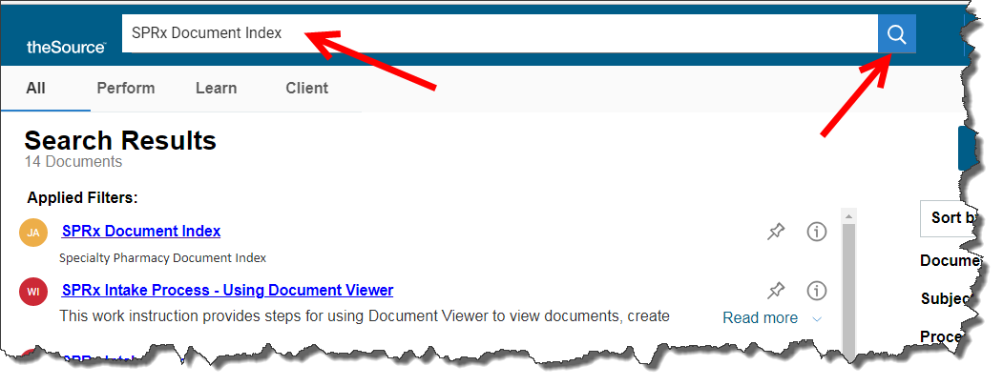

* You can filter search results by type of document by clicking one of the following:
  + - **All (No Filter Applied):**  Returns Announcements plus all other document types below.
    - **Perform Filter:**  Returns documents that help you perform your job like Work Instructions and Job Aids.
    - **Learn Filter:**  Returns documents used in Training including training modules, guides, and videos - anything you might reference when you “Learn” a job.
    - **Client Filter:**  Returns Client specific materials, such as CIFs (Client Information Forms) and associated documents, like client specific drug lists and client sample letters mailed to members of a client’s plan.

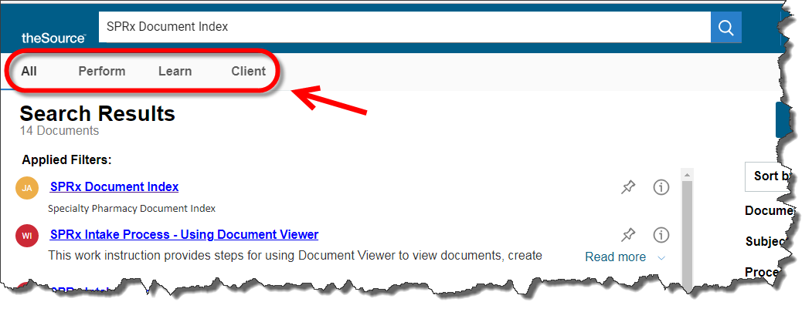

**Note:** Perform, Learn, and Client may also be selected within the Search bar, before entering the document information.

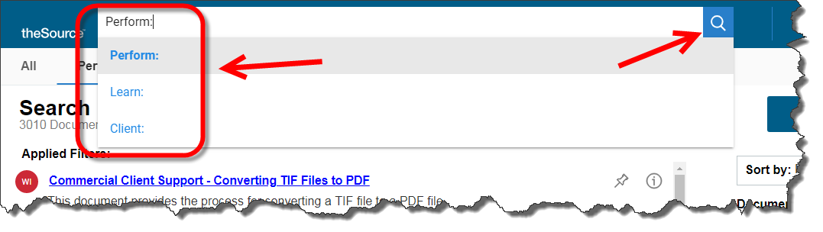

1. The **Sort By** feature allows you to filter Search results by:

* Relevance
* Date Modified
* Title

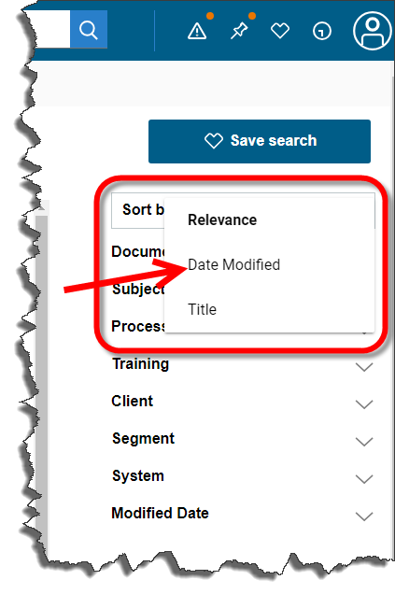

1. The **Data Facets** feature allows users to set additional filters for the Search by selecting from dropdowns for:

* Document Type
* Subject
* Process
* Training
* Client
* Segment
* System
* Modification Date

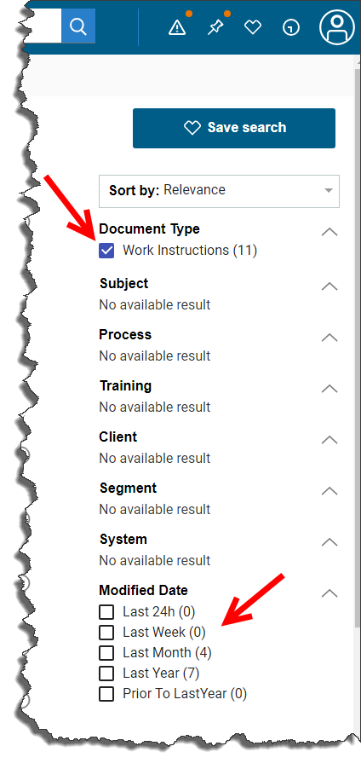

1. Once the Search results display, press **Ctrl+f** and enter text into the field to search the page for the specific text. The text will highlight. Arrow up or down to locate the specific document.

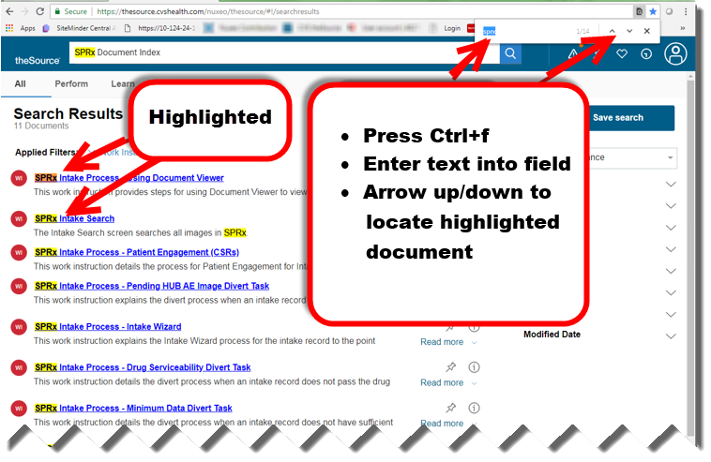

 Your next challenge on the quest to becoming a Certified theSource Wizard is to save your **Favorite Searches**, which will save you time in the future:

* Perform a search
* Click **Save Search**



* Name your search
* Click **Save**
* Access your saved searches using the **Favorite Searches** icon



Not to Be Reproduced or Disclosed to Others without Prior Written Approval

**ELECTRONIC DATA = OFFICIAL VERSION / PAPER COPY = INFORMATIONAL ONLY**